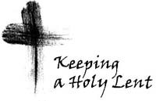

**Lent** begins on March 5th, Ash Wednesday. Mass will be celebrated at 9:00 a.m. and 7:00 p.m. Ash Wednesday is not a Holy Day of Obligation but it is an important day to start your Lenten Season. It is a day of fasting and abstinence.

**Fasting and Abstinence** during Lent is on Ash Wednesday and Good Friday. Catholics between the ages of 18 and 59 are permitted one full meal and two lesser meals per day (which together should not equal one full meal), with no eating between meals. All other Fridays are days of abstinence, which means to abstain from eating meat. Catholics who are 14 years or older should abstain from meat entirely. Soups and gravies made from meat are permitted.

**Lenten Activities**

**Daily Mass:** Monday, Tuesday, Friday at 8:00 a.m., Wednesday at 6:00 p.m. and Thursday at 9:00 a.m. Make this Lent a Retreat. Allow the Lord to draw you closer to His Heart each day through Word and Sacrament.

**Stations of the Cross:** Friday’s at 12:00 noon in the Garden, except for Friday, March 11 when they are at 4:00 p.m. On Good Friday only, an additional 7:00 p.m. Stations will be in the Church. Come make a spiritual pilgrimage of prayer each Friday and meditate upon the final hours of our Lord’s life as he carried the cross for our sins.

**Eucharistic Adoration:** A time of prayer and contemplation in the Presence of Our Eucharistic Lord. Adoration of the Holy Eucharist will be every Wednesday from 5:00 to 5:50 p.m. during lent.

**Penance service:** Sunday March 16th at 4:00 p.m. The Lord always showers us with His grace. During Holy Week and Easter the Lord’s graces flow in abundance. Prepare yourself to fruitfully receive those graces during the celebration of the Lord’s passion, death, and resurrection by purging yourself of your sins at our Lenten penance service. Several priests will be available to hear your confession and grant absolution.

**Fish Fry:** Friday, March 11, from 4:45 – 7:00 pm. Proceeds from the Fish Fry are used to support our High School Age Youth Ministry. This Fish Fry will follow a special time for the Stations of the Cross at 4:00 p.m. on March 11th.

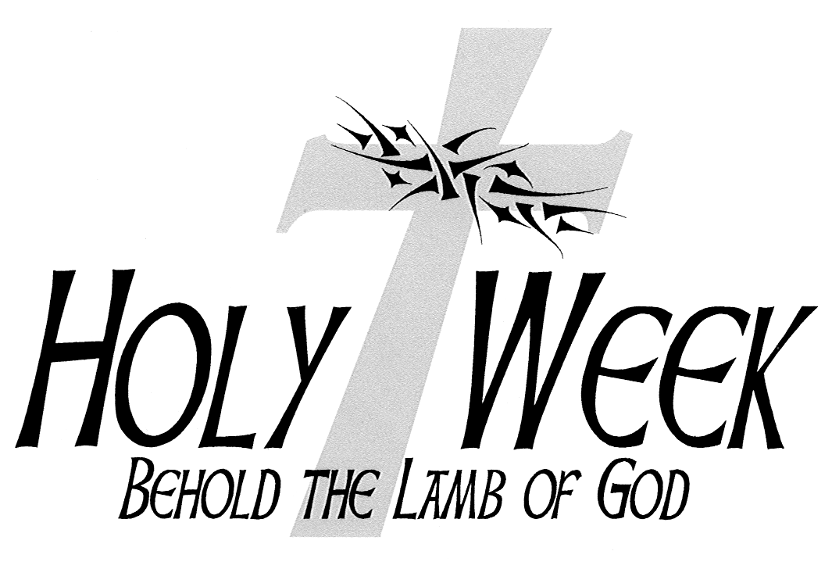

**2025**

**5:00 – 5:50 p.m.** Eucharistic Adoration – Every Wednesday during Lent

Wednesday – April 16th

**11:00 a.m.** Chrism Mass at the Cathedral-Basilica of St. Augustine

**5:00 – 5:30 p.m.** Confessions

**5:00 – 5:50 p.m.** Eucharistic Adoration

**6:00 p.m**. Mass

Holy Thursday – April 17th

(No Morning Mass)

**8:00 a.m.** Morning Prayers

**7:00 p.m.** Mass of the Lord’s Supper

Adoration following Mass until 10:00 p.m.

Good Friday – April 18th

A Day of Fast and Abstinence

(No Morning Mass)

**8:00 a.m.** Morning Prayers

**12:00 p.m.** Stations of the Cross (in the Garden of the Cross)

**3:00 p.m.** Passion of the Lord (with Holy Eucharist)

**7:00 p.m.** Stations of the Cross (in the Church)

Holy Saturday – April 19th

**(*No Confessions on Holy Saturday)***

**8:00 a.m.** Morning Prayers

**8:30 p.m.** The Easter Vigil Mass

Easter Sunday – April20th

**9:00 a.m.** Mass of the Resurrection

**10:15 a.m.** Easter Egg Hunt

**11:00 a.m.** Mass of the Resurrection

Divine Mercy Sunday – April 27th

**3:00 – 4:00 p.m.** Adoration and Chaplet of Divine Mercy